**Week 3**

**Exercise 1: Configuring a Basic Spring Application**

Scenario:

Your company is developing a web application for managing a library. You need to use the Spring Framework to handle the backend operations.

Steps:

1. Set Up a Spring Project:

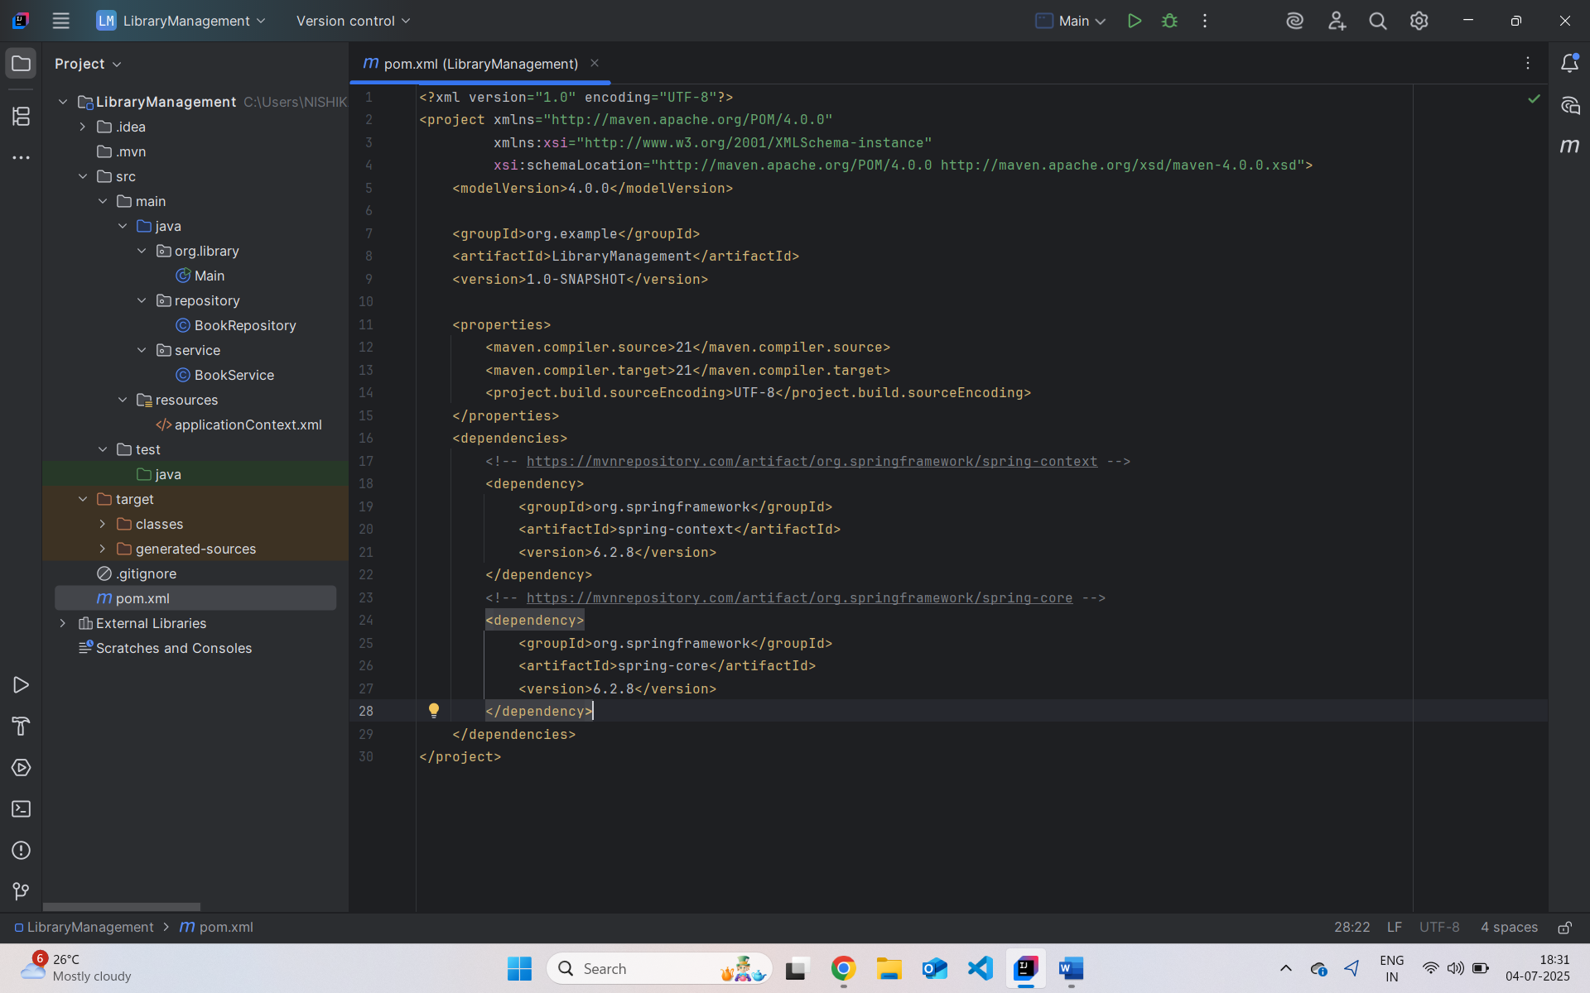

1. Configure the Application Context:

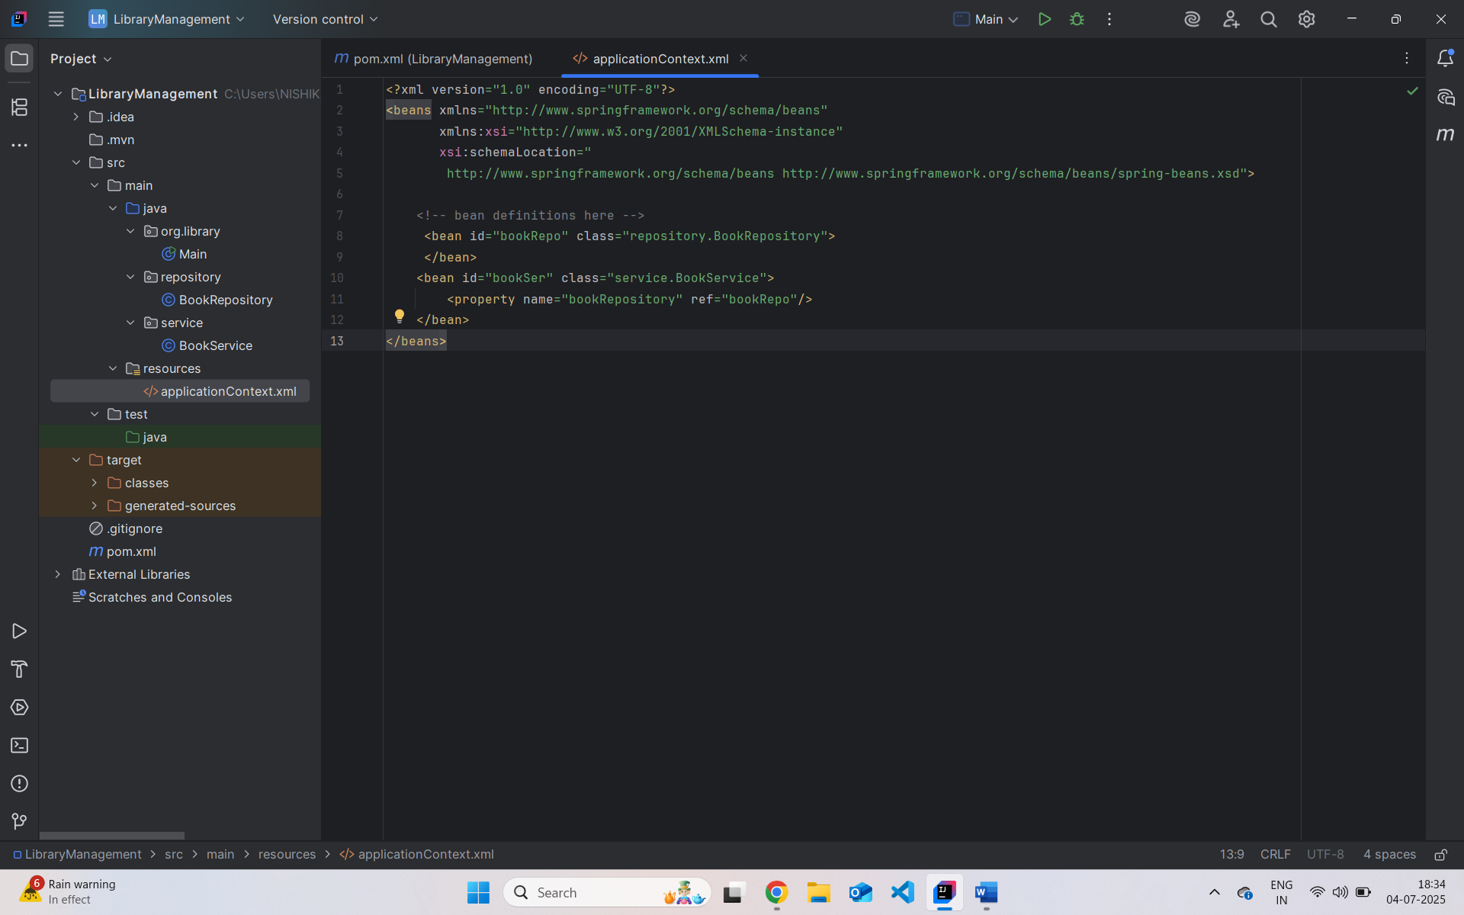

1. Define Service and Repository Classes:

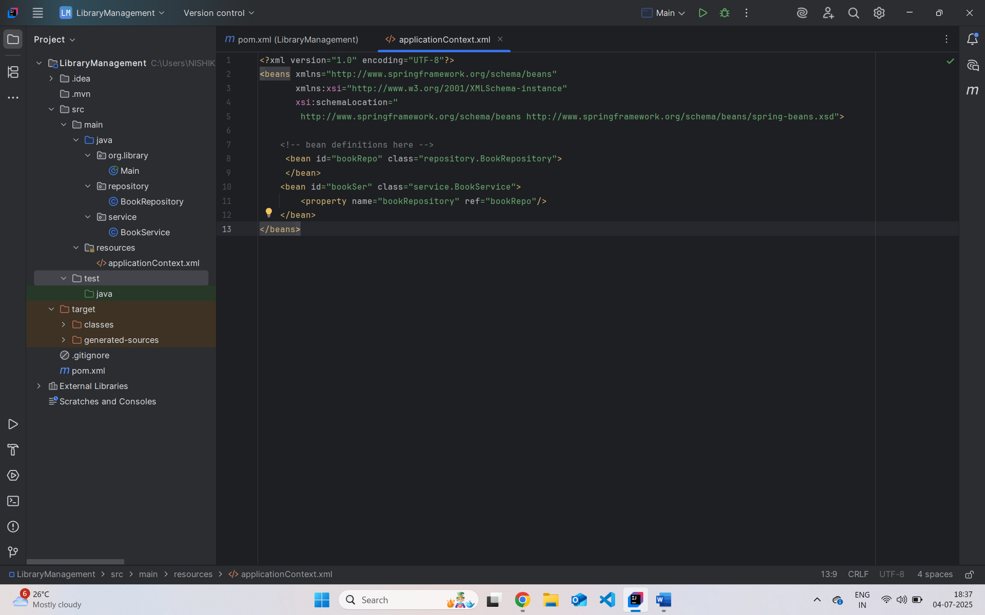

1. Run the Application:

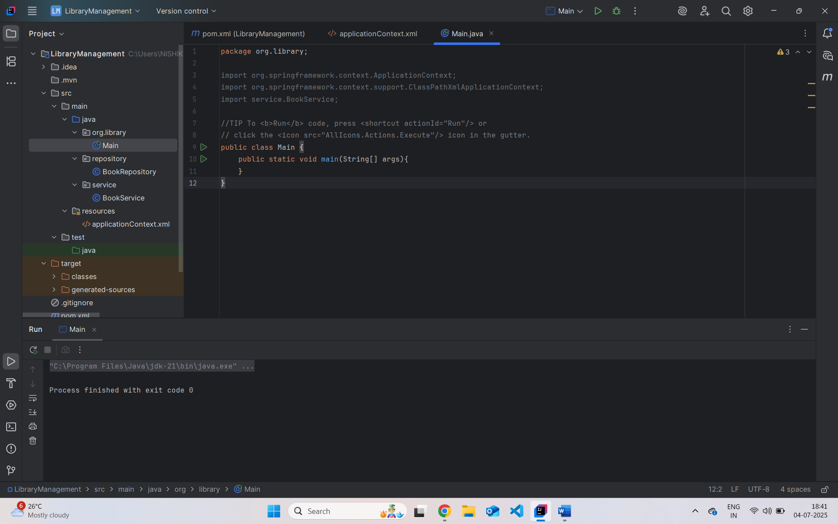

**Exercise 2: Implementing Dependency Injection**

Scenario:

In the library management application, you need to manage the dependencies between the BookService and BookRepository classes using Spring's IoC and DI.

Steps:

1. Modify the XML Configuration:

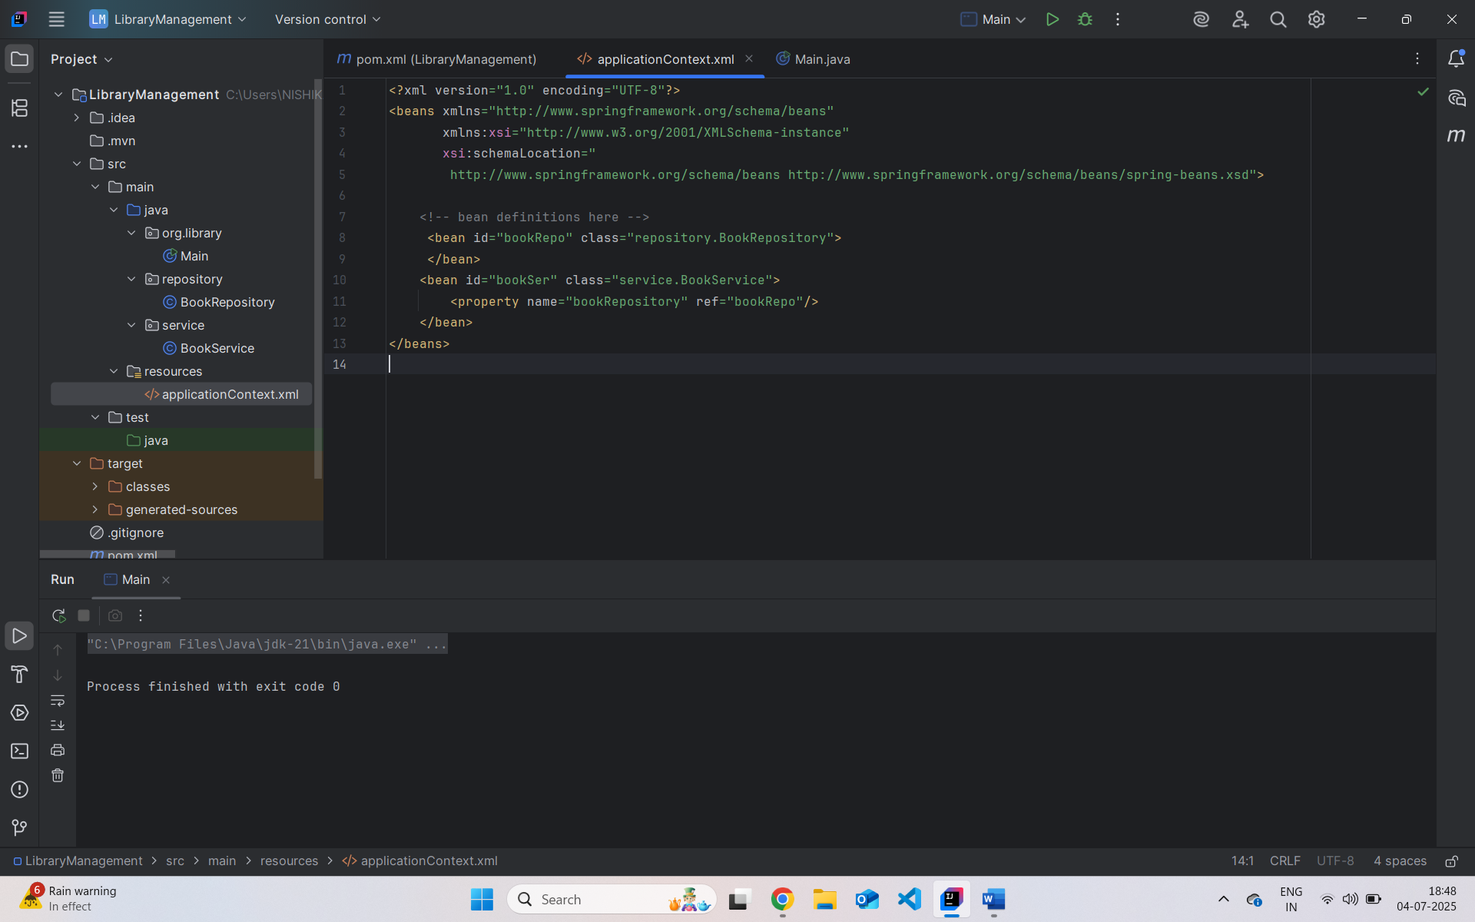

1. Update the BookService Class:

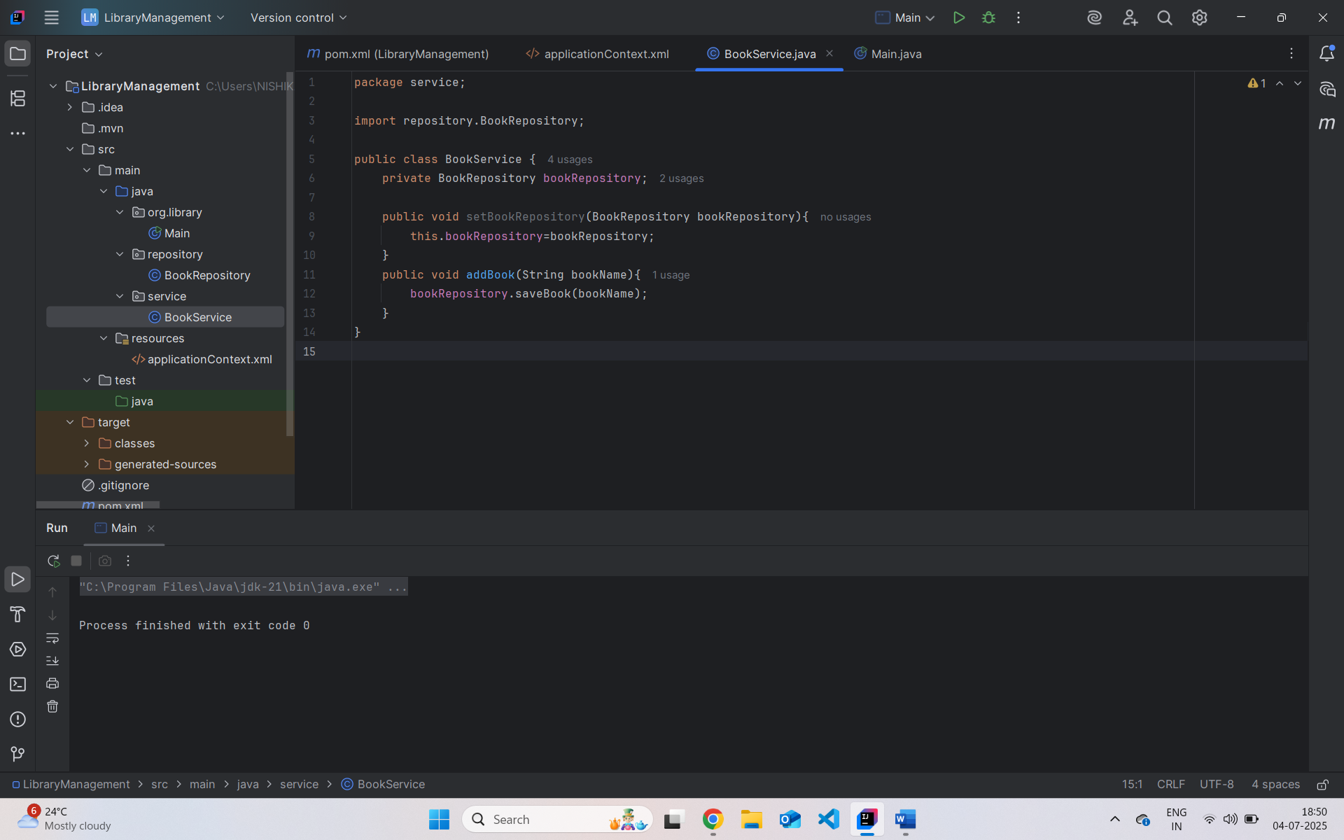

1. Test the Configuration:

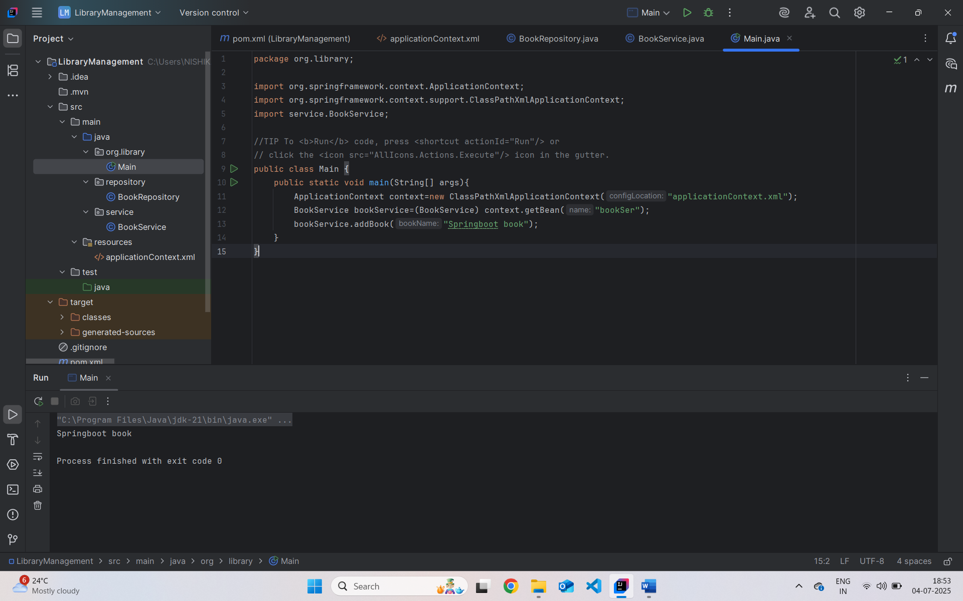

**Exercise 4: Creating and Configuring a Maven Project**

**Scenario:**

You need to set up a new Maven project for the library management application and add Spring dependencies.

1. Create a New Maven Project.
2. Add Spring Dependencies in pom.xml.
3. Configure Maven Plugins.

